IBM Agentic AI Assignment

Name: Pranav Suresh
Email-id: pranav.suresh2024@vitstudent.ac.in
Batch: Agentic AI – 04

- Intent Classification
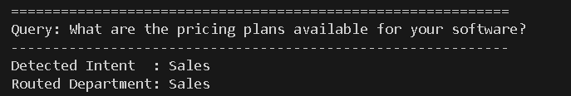
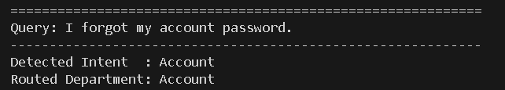
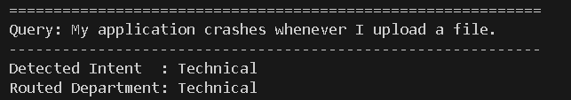
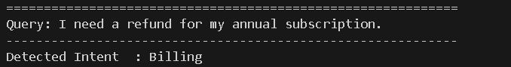


- Routing
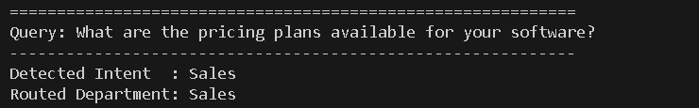
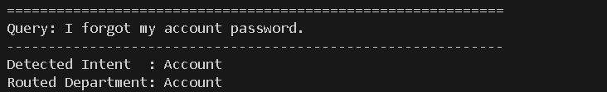
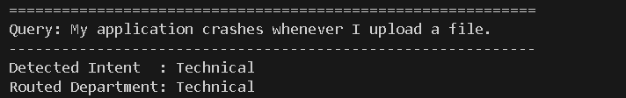
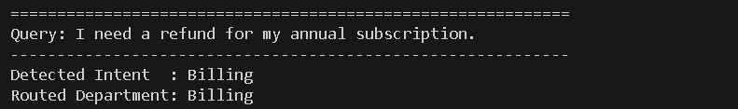
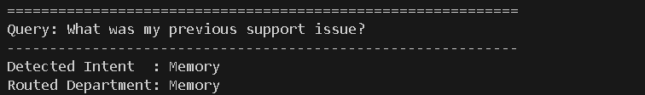
- Sales Agent
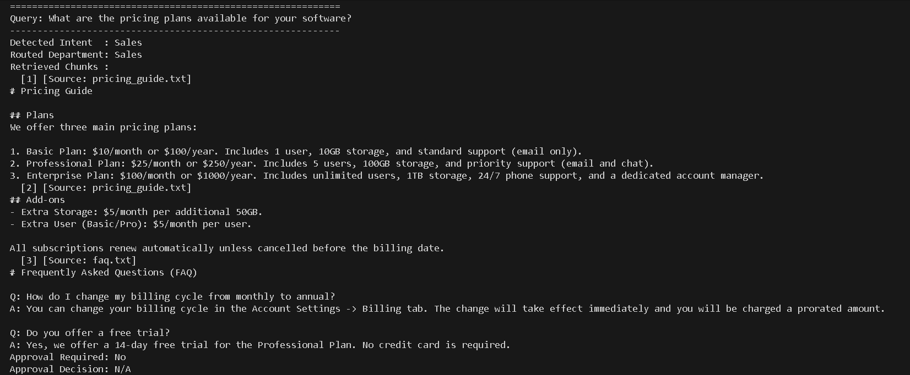
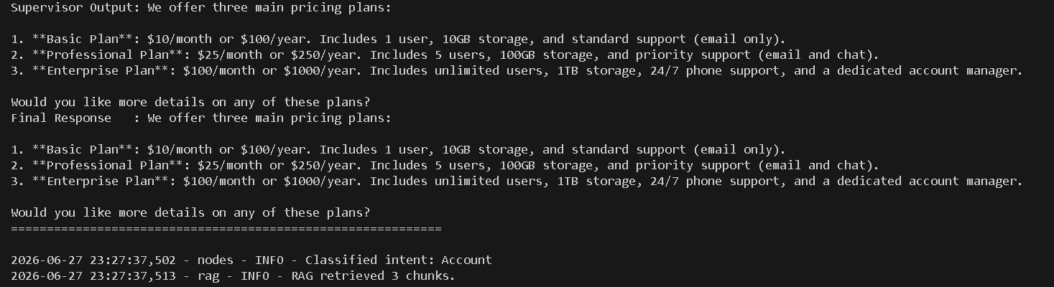
- Account Agent
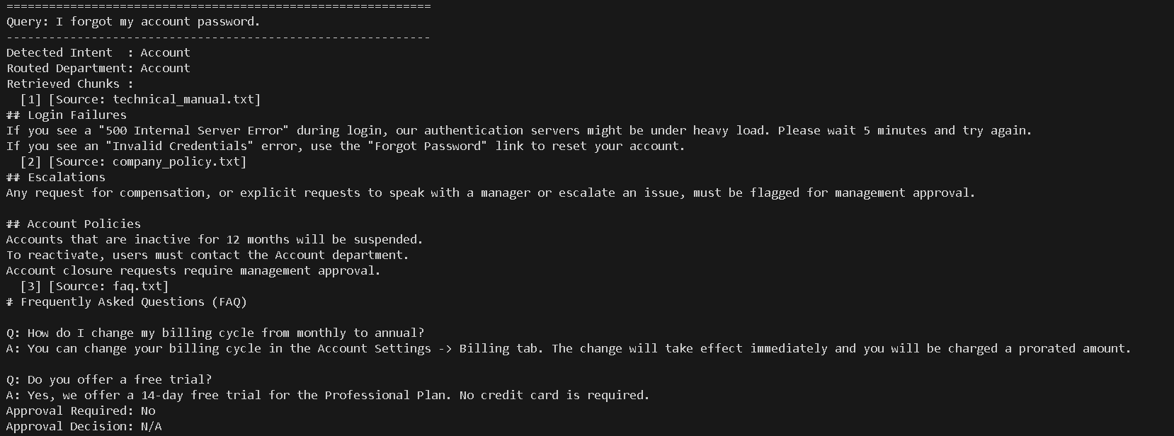
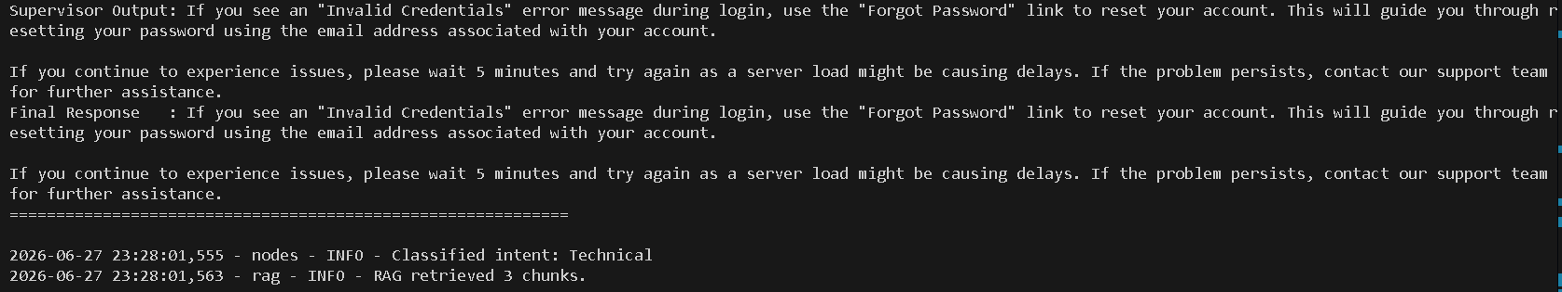
- Technical Agent
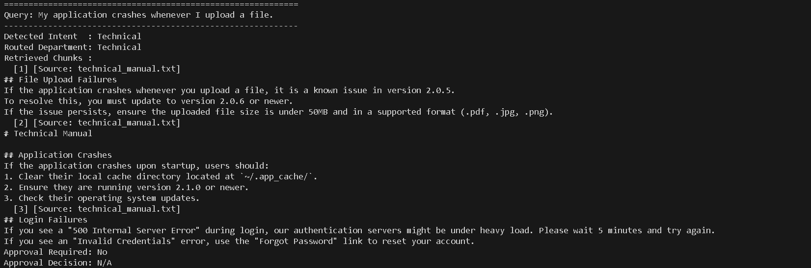
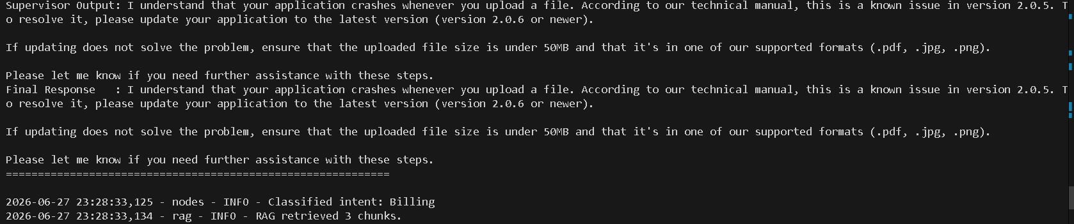
- Billing Agent
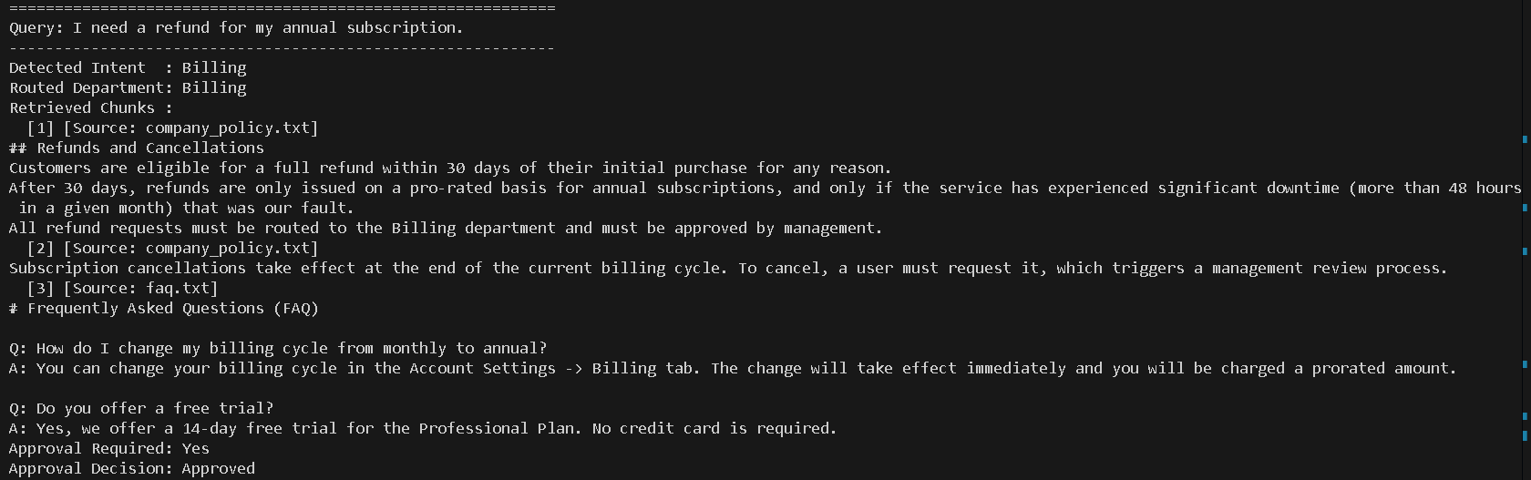
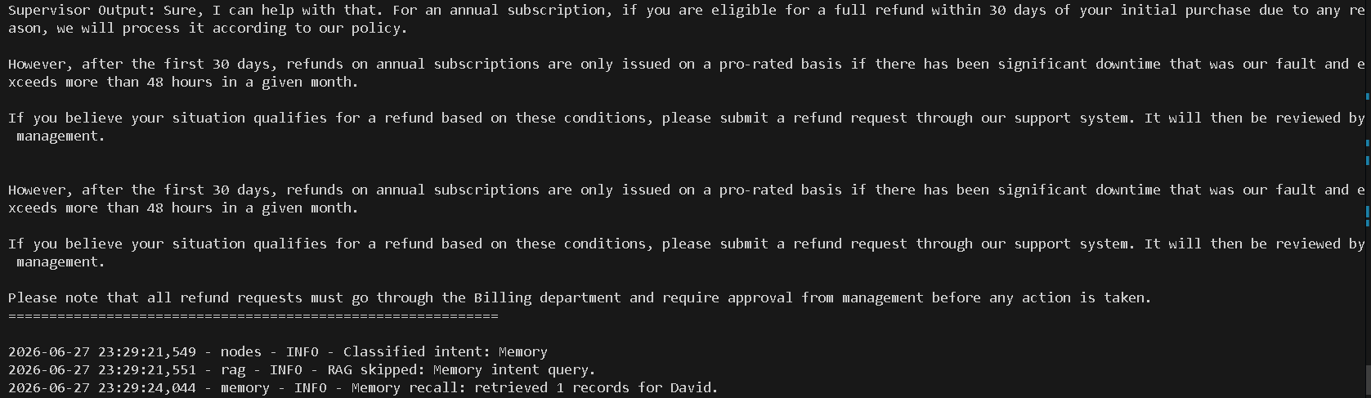
- RAG Retrieval
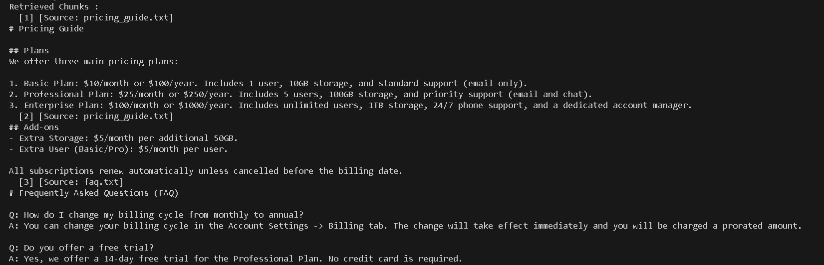
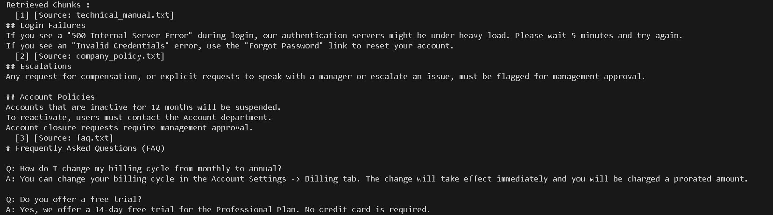
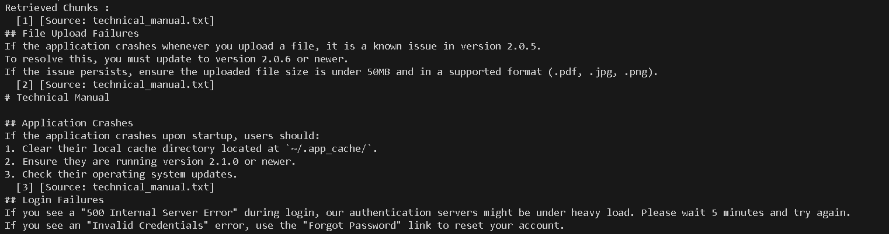
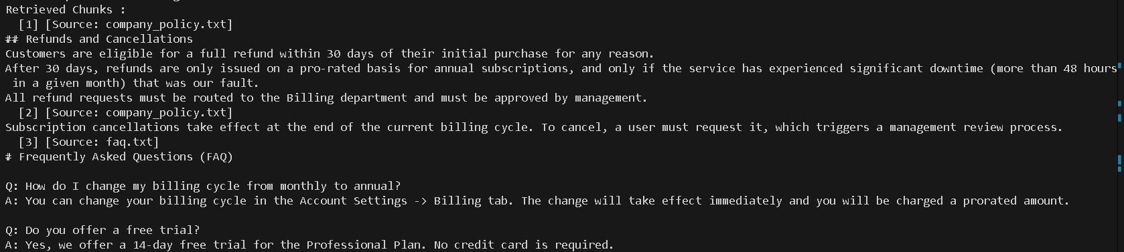
- Human Approval
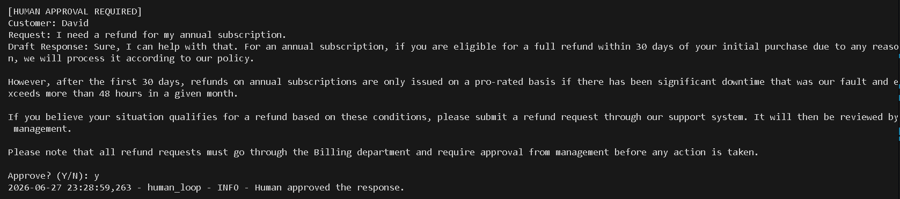
- Memory Recall
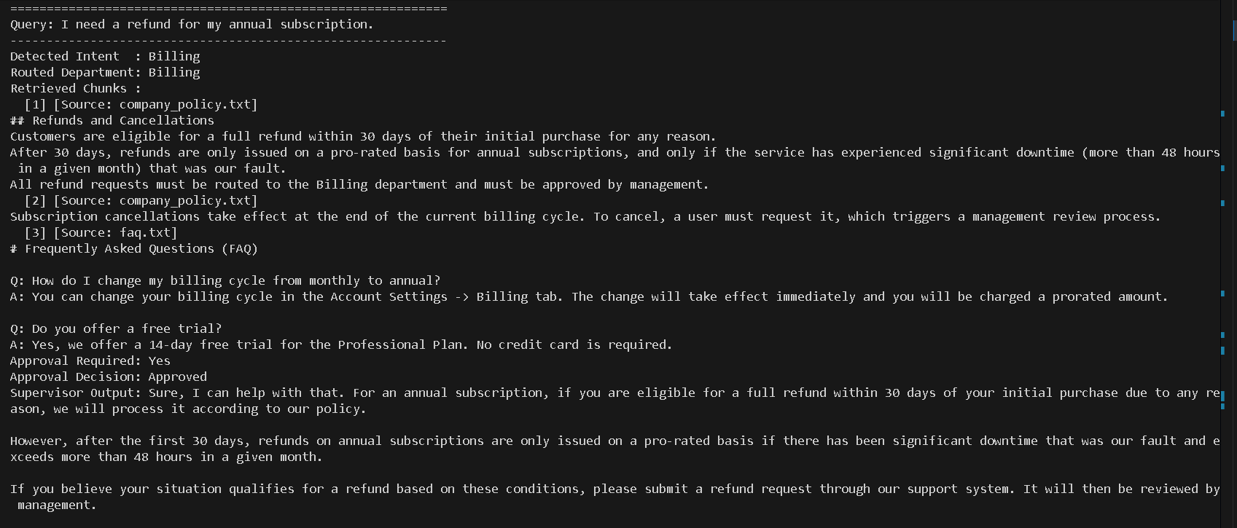
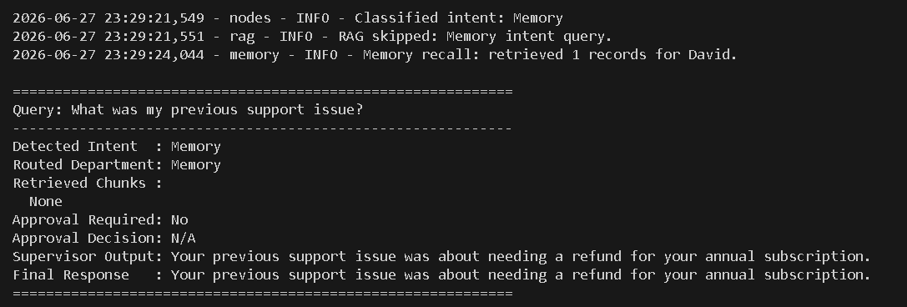
- Supervisor Agent
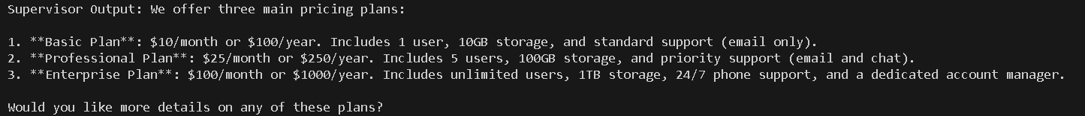
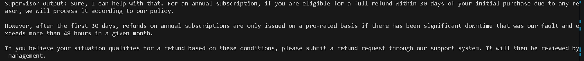

- SQLite DB
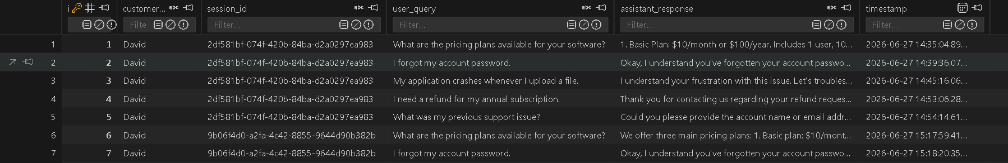
- Knowledge Base


